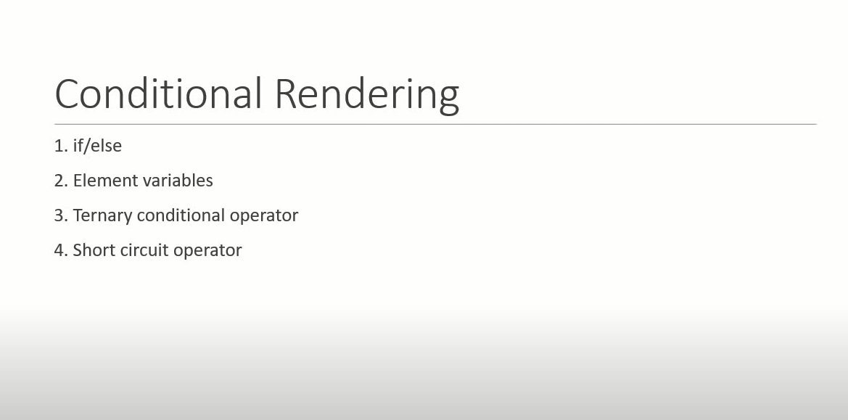

1. If else

* Id else condition not work inside JSX, because JSX is just syntactic sugar for function call and object construction adding if else statements with JSX is not valid that is the reason we have if else statement outside the Jsx and entire return statement containing Jsx
* Better approach is element variable as compare to if else.

1. import React, { Component } from 'react'
2. class UserGreeting extends Component {
3. constructor(props) {
4. super(props)
6. this.state = {
7. isLoggedIn:true
8. }
9. }
11. render() {
12. if(this.state.isLoggedIn){
13. return <div>Welcome Subhishek</div>
14. }else{
15. return <div>Welcome Guest</div>
16. }
17. }
18. }
19. export default UserGreeting

2. Element Variable

- Use Javascript variable to store element

- This is also help to render whole component or only part of the component as well.

import React, { Component } from 'react'

class UserGreeting extends Component {

    constructor(props) {

      super(props)

      this.state = {

          isLoggedIn:false

      }

    }

  render() {

let message

if(this.state.isLoggedIn){

message=<div>Welcome Subhishek</div>

}else{

    message=<div>Welcome Guest</div>

}

return <div>{message}</div>

  }

}

export default UserGreeting

3. ternary operator

import React, { Component } from 'react'

class UserGreeting extends Component {

    constructor(props) {

      super(props)

      this.state = {

          isLoggedIn:false

      }

    }

  render() {

  //this is example of ternary operator

  return this.state.isLoggedIn ? (

    <div>Welcome Subhishek</div>

) : (

    <div> Welcome Guest</div>

)

}}

export default UserGreeting

4. Short Case Operator:

- This approach is just specific case of ternary operator

- If u want to render something or nothing you make use of the short circuit operator

- for example if user login I have to show message otherwise nothing

return this.state.isLoggedIn && <div>welcome Subhishek</div>

In this statement it will check first if its true then it will go after “&&”

import React, { Component } from 'react'

class UserGreeting extends Component {

    constructor(props) {

      super(props)

      this.state = {

          isLoggedIn:true

      }

    }

  render() {

//this is example of Short Case Operator

return this.state.isLoggedIn && <div>welcome Subhishek</div>

}

}

export default UserGreeting